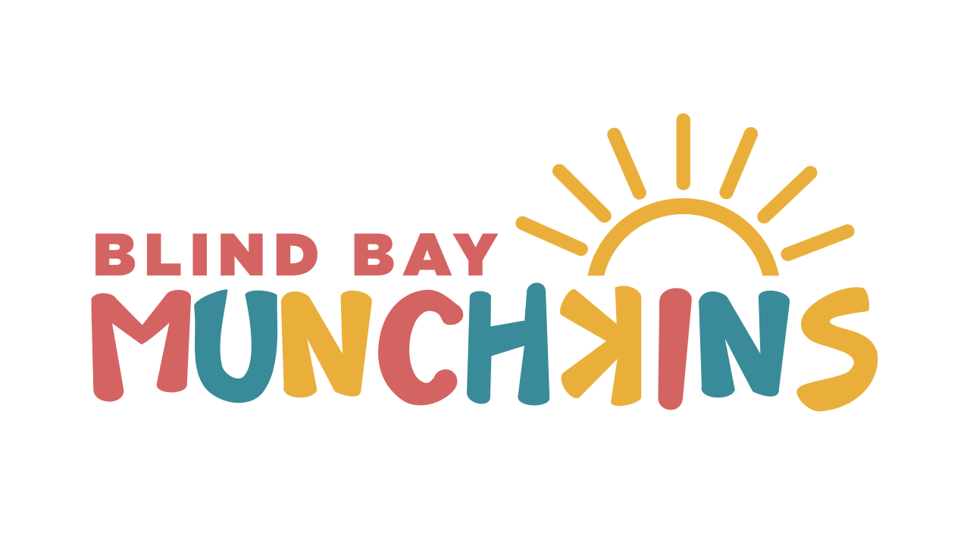
The warm weather is finally here! We are outside exploring and enjoying all our moments to the fullest! With this warm/ rainy weather comes outfit changes, shoe changes, sunscreen, mud, boots, sandals and hats! We really never know what we are going get these days!
Please make sure your kids are prepared daily with:
- Appropriate outside wear (rain gear, coat, boots or shoes, sweater etc...)
- Spare clothes in a Ziploc bag labeled in their bag
- Water bottle labeled
- Hat labeled
- Sunscreen APPLIED before drop off! We will re-apply mid-morning.
- Almost time for bathing suits in bags too! LABELED PLEASE (If you have an extra one you can just leave this at daycare in Ziploc. LABELED 😊 )
On that note, please make sure all your children’s belongings are labeled! We have a fundraiser going with Mabels labels if you'd like to order from there (Blind Bay Munchkins) or a sharpie does wonders😀
If you are sent home with daycare spares, please wash and send back! We go through lots in a day and can't replenish unless they are sent back 😀
We have been busy exploring all things, we tried hatching some eggs and butterfly larvae, some went well and others were not as successful. We are going to try the eggs again this week- in a month or so we should have some baby chicks to play with!
We have a field trip planned to the Llama sanctuary in Chase on June 3rd. We are asking anyone who can- to send their child with a $5.00 donation for the llama sanctuary- (this is the amount they have asked for per child) If your family cannot cover this cost, Munchkins will cover the cost for your child. We also ask if your child is attending this day if you can remember to please bring a few carrots and an apple for the exchange program the farm offers on the day of! We bring some and exchange them for precut ones we feed to the animals that day! No worries if anyone forgets or just can’t! The Llama sanctuary is a not-for-profit rescue and rehabilitation center for llamas and alpacas in need. We are looking forward to visiting and seeing what it's all about and helping where we can 😊
Also, please remember to keep toys at home, we have lots of things to play with at school and we don’t want any tears over misplaced toys or items from home. We thank you all for understanding and keeping those toys at home or in the car and re-united at pick up!
We are on the hunt for some 2nd hand strider bikes if anyone has any they are done with or sees them while on a garage sale wander over the weekends! Please think of us 😊 we will reimburse reasonable amounts!
We look forward to this new season of warmth and exploring the outdoors with these sweet children we have the pleasure of spending our days with. We will be baking, creating, crafting, planting, watching new life hatch, grow and of course field tripping’ among other things!

- Reminder we are closed on June 17th. This long weekend gives our educators a chance to recoup and come back better and well rested to give your children the best care.

